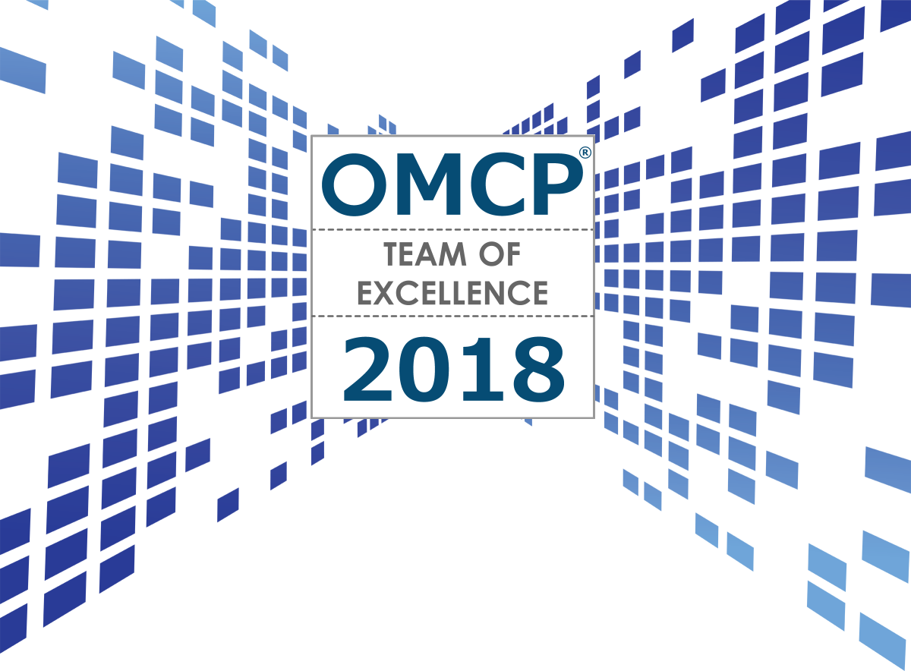

ENTRY APPLICATION
Entry Deadline: FEBRUARY 11, 2018
Awards Announcement: MARCH 2018
This entry form serves as a template to get started on your Team of Excellence Award entry documentation. You can upload this single document, to cover both the executive summary and supporting data requirements, or combine separate data in the other suggested formats in a single zip file. (Maximum length: 3 Pages /Slides in PDF or PPT/PPTX, or 3 Tab Limit on CSV/XLS/XLSX files only.) You must also upload a company logo with awards entries.

- PLEASE REVIEW all of the individual category descriptions prior to submission at https://omcp.org/awards-excellence-digital-marketing-standards/ for explicit submission requirements and specific data / criteria the judges will be looking for in each category. Judges will be considering:
  - Volume of staff trained
  - Volume of staff certified
  - Exam pass rates
  - Course completion rate
  - Contribution to (or adherence to) standards
  - Innovation in training methodology

- **DO NOT EXCEED** 5 pages in total (not including this cover page).

- When complete, submit these materials and entry form here: https://omcp.org/awards-excellence-digital-marketing-standards/

- Initiatives / Trainings/Exams submitted for consideration must have been executed between January 1, 2018 and January 1, 2019
  - Applications for Team of Excellence awards should also use these dates as a guideline when submitting supporting materials for specific accomplishments and/or research performed.
  - Visit our FAQ or email info@omcp.org with additional questions.
ENTRY DETAILS

CONTACT NAME
CONTACT EMAIL
COMPANY NAME*

Who can enter? Company or agency must employ 10 or more staff that offer online marketing, digital advertising, or digital media services that include at least four of the disciplines covered by the OMCP competency and certification standards. Training or exams mush have taken place in the calendar year 2018.

TRAINER REFERENCES & CONTACT INFO
Please provide the name and contact information for lead trainer/institution:

CATEGORY
Place an [X] next to the category you are submitting an entry application for.

ENTRY FOR: | CATEGORY NAME
 | Volume of staff trained
 | Volume of staff certified
 | Exam pass rates
 | Course completion rate
 | Contribution to (or adherence to) standards
 | Innovation in training methodology

While these awards are from OMCP.org, the nominee does not have to be a current member of the organization.

EXECUTIVE SUMMARY (750 WORDS or LESS)
Summarize the main objectives, innovative strategies employed, and tactics implemented in your online marketing training program

RESULTS & SUPPORTING DOCUMENTATION
In lieu of submitting separate supporting data and/or charts in EXCEL, PDF, PPT or other formats, you may include a summary of success metrics and/or embed supporting graphics on the following pages.
ALL DATA IS USED FOR JUDGING PURPOSES ONLY & WILL NOT BE SHARED PUBLICLY WITHOUT CONSENT OF APPLICANT AND/OR CLIENT.

SUMMARY OF RESULTS: (list up to 5 bullet points)

SUPPORTING CHARTS / GRAPHS:

SUPPORTING CHARTS / GRAPHS:

Note: Credit to Search Engine Land Landy Awards for much of the content/guidelines in this form.

